目录

Model Layer 1 2

Model Layer 2 3

Model Layer 3 4

Model Layer 4 5

4.1 lateral Control Parameters 6

4.2 Compute Control Metrics 8

4.2.1 Effective Lookahead Time and Effective Lookahead Distance 10

4.2.2 LKA Offset Computation 11

4.2.3 TJA Offset Computation 13

4.2.4 Slip Compensation 13

4.2.5 Create Control Metrics 14

4.3 Path Controller 15

4.3.1 LocalOffset and VLat Controllers 16

4.3.1.1 LocalOffsetController 16

4.3.1.2 VlatController 17

4.3.1.3 CalcRampOver 18

4.4 Limit and Format Output 18

4.4.1 Determine PinionAngle Limitation 19

4.4.2 Dynamic Saturation 19

## Model Layer 1

The path of Layer 1 is “VCCComposition->ASDM”. The block including 23 input signals and 1 output signals. The figure is as follow

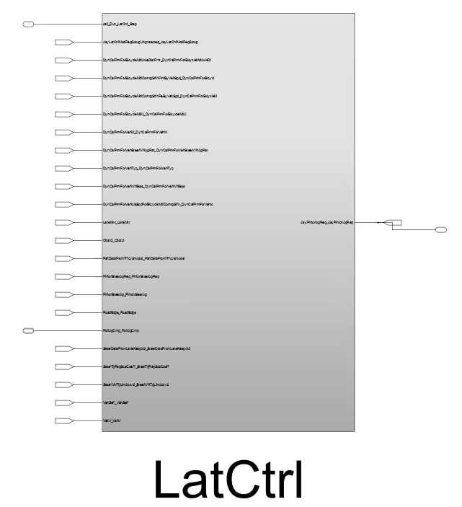

## Model Layer 2

The path of Layer 2 is “VCCComposition->ASDM->LaneKeepAidCtrl”. This signals are the same as Layer 1. Just the activation function is represented by a function.

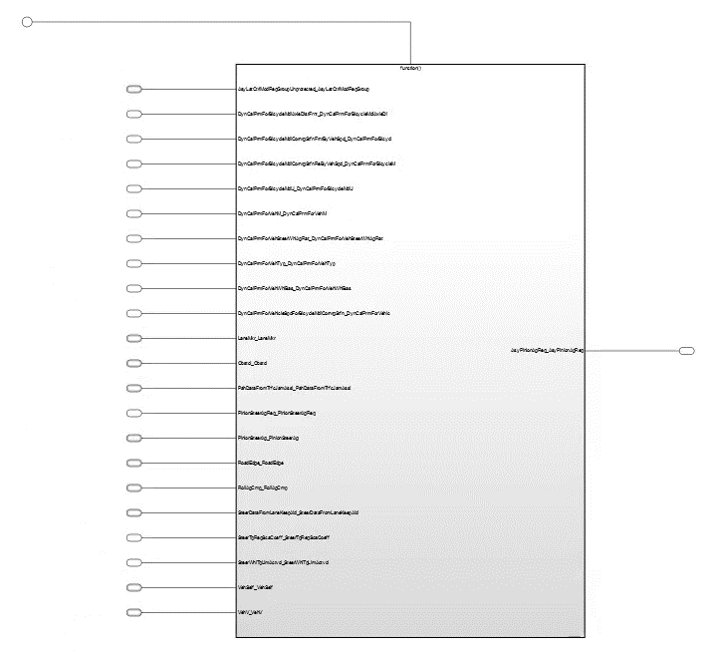

## Model Layer 3

The path of Layer 3 is“VCCComposition->ASDM->LatCtrl->Run_LatCtrl_Step_Func”. All signals is the same as Layer 2.

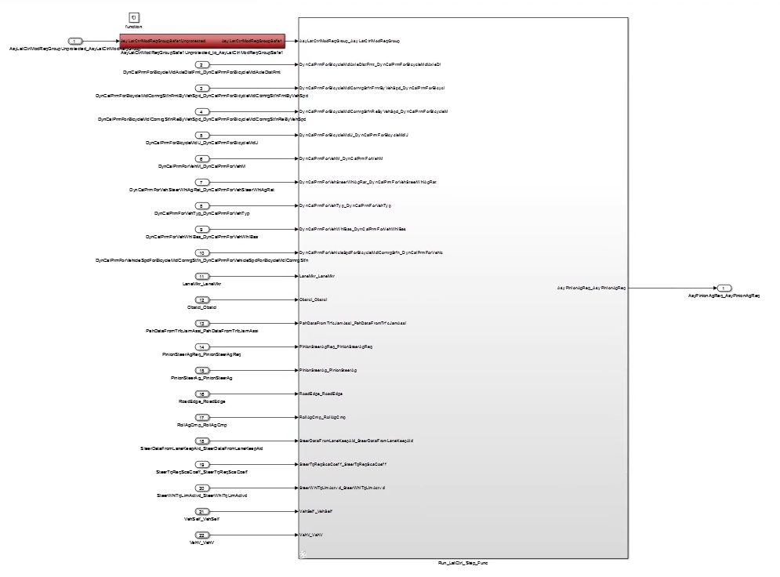

## Model Layer 4

Figure 4.1 shows the top level of LatCtrl. The LatCtrl model encloses many subsystems and Figure 4.2 illustrates how some of these subsystems relate to the linear control system. The LatCtrl model basically consists of four subsystems, illustrated in Figure 4.3 and named Lateral Control Parameter, Compute Control Metrics, Path Controller and Ramp In and Format Output. Each of these subsystems are described in Section 4.1 to Section 4.4.

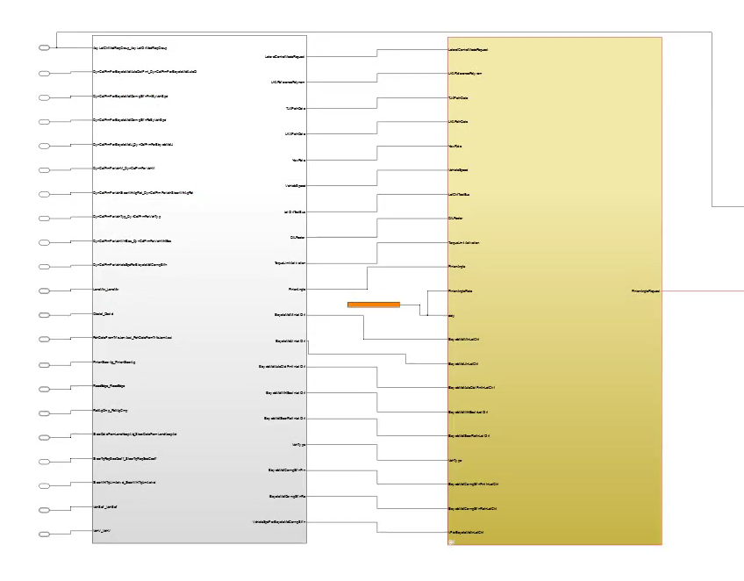

Figure 4.1 left is Signal Extraction and Right is LatCtrl



Figure 4.2 Illustration of how some of the subsystems in LatCtrl relate to the illustration of the linear parts of the lateral controller.

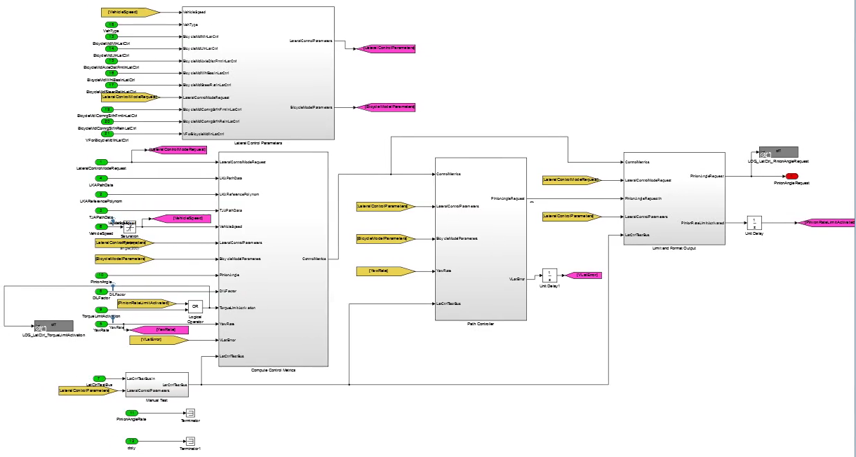

Figure 4.3 The LatCtrl Simulink model basically consists of the subsystems Lateral Control Parameters, Compute Control Metrics, Path Controller and limit and Format Output.

### 4.1 lateral Control Parameters

Path: LatCtrl – Lateral Control Parameters

The Lateral Control Parameters – block creates two vectors signals named LateralControlParameters and BicycleModelParameters. These vectors signals contain parameters that are used in the lateral control. The vector signal BicycleModelParameters contains all constant values found in Table 4.1 as well as a constant named SteerRatio which is the gear ratio between the wheels and the steering wheel. The content of the vector signal LateralControlParameters vector is not further described here but the meaning of each signal is explained in its real context, that is, wherever it is used in the controller.

|  |  |  |  |  |
| --- | --- | --- | --- | --- |
| Input | Signal | Dim. | Data type | Description |
| VehicleSpeed |  | 1 | single | Ego vehicle speed |
| VehType |  | 1 | single | Type of the Vehicle |
| BicycleMdlMlnLatCtrl |  | 1 | single | Vehicle weight |
| BicycleMdlJlnLatCtrl |  | 1 | single | Vehicle inertia around z-axis |
| BicycleMdlAxleDistFrntlnLatCtrl |  | 1 | single | Distance between front axle and contre of gravity |
| BicycleMdlWhlBaslnLatCtrl |  | 1 | single | Vehicle wheelbase |
| BicycleMdlSteerRatlnLatCtrl |  | 1 | single | Vehicle steering wheel angle ratio |
| LateralControlModeRequest |  | 1 | single | Record of AS lateral mode request,with checksum and counter |
| BicycleMdlCornrgStfnFrntlnLatCtrl |  | 1 | single | The front cornering stiffness |
| BicycleMdlCornrgStfnRelnLatCtrl |  | 1 | single | The rear cornering stiffness |
| VForBicycleMdlinLatCtrl |  | 1 | single | Vehicle speed break points used to find the cornering stiffness values for front and rear.The values are defined by LatCtrl for each vehicle type |

|  |  |  |  |  |
| --- | --- | --- | --- | --- |
| Output | Signal | Dim. | Data type | Description |
| LateralControlParameters |  | 73 | single | Parameters for the LatCtrl |
| BicycleModelParameters |  | 7 | single | Parameters for the BicycleModel |

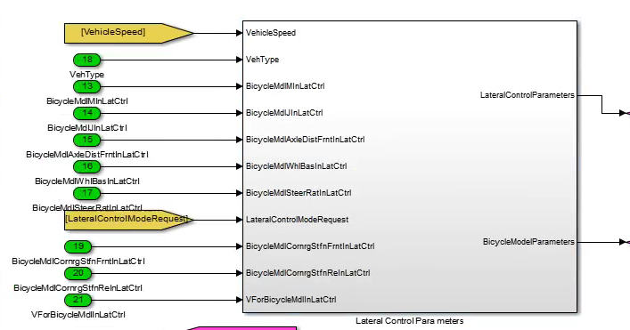

Figure 4.4 The Lateral Control Parameters Simulink model basically consists of All parameters for the control system

### 4.2 Compute Control Metrics

Path: LatCtrl – Compute Control Metrics

The Compute Control Metrics – block compute metrics that are to be used in the Path Controller – block, such as the local offset Δy and the lookahead offset yL2. The content of the Compute Control Metrics-block is shown in Figure 4.4. The local offset and the lookahead offset are computed either in the block named LKA Offset Computation or in the block named TJA Offset Computation,depending on if the lateral controller is to be used with the LKA function or the TJA function. The two subsystems mentioned are described in Section 4.2.2 and Section 4.2.3 respectively. First Section 4.2.1 describe how the effective lookahead distance Leff is computed. As previously described, this distance is used when evaluating the lookahead distance yL2.

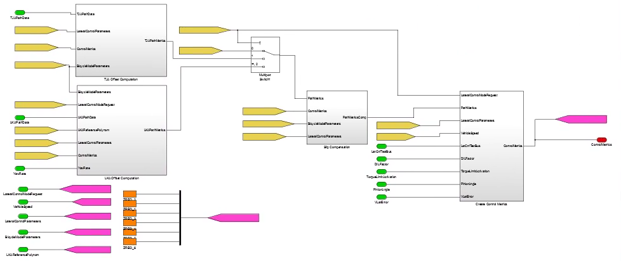

Figure 4.4 Content of the Simulink Model named Compute Control Metrics.

|  |  |  |  |  |
| --- | --- | --- | --- | --- |
| Input | Signal | Dim. | Data type | Description |
| LateralControlModeRequest |  | 1 | single | Record of AS lateral mode request |
| LKAPathData |  | 1 | single | LKAPathData form LKA control |
| LKAReferencePolynom |  | 1 | single | Polynomial of Reference road |
| TJAPathData |  | 1 | single | TJAPathData form LKA control |
| VehicleSpeed |  | 1 | single | Speed of Vehicle |
| LateralControlParameters |  | 1 | single | Para for the control |
| BicycleModelParameters |  | 1 | single | BicycleMode Para for the control |
| PinionAngle |  | 1 | single | PinionAngle |
| DILFactor |  | 1 | single |  |
| TorqueLimitActivation |  | 1 | single |  |
| YawRate |  | 1 | single | Yawrate of the ego vehicle |
| VLatError |  |  | single | Error of the Vlat |
| LatCtrlTestBus |  |  | single | Data for test |

|  |  |  |  |  |
| --- | --- | --- | --- | --- |
| Output | Signal | Dim. | Data type | Description |
| ControlMetrics |  | 1 | single | Compute value for the model |

#### 4.2.1 Effective Lookahead Time and Effective Lookahead Distance

This section show how the corresponding metric to L and T are computed in LatCatrl, the metrics are referred to as the effective lookahead distance Leff and the effective lookahead time Teff respectively.

Pseudo code is as follows:

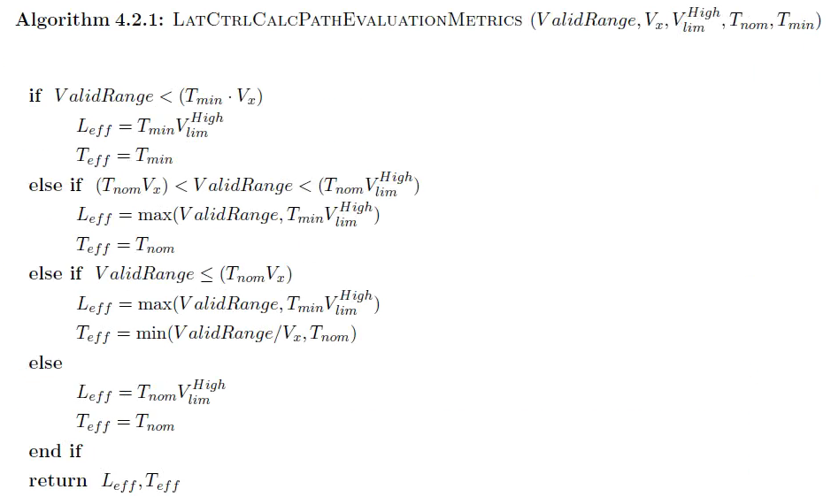

#### 4.2.2 LKA Offset Computation

Path: LatCtrl – Compute Control Metrics – LKA Offset Computation

The LKA Offset Computation-block computes the local offset Δy, thelookahead offset yL2, the local heading LocalHeading, the effective lookahead time Teff and the effective lookahead distance Leff.

LateralControlModelRequest Indicates which mode latctrl should run in and should be interpreted as follow:

|  |  |  |  |  |
| --- | --- | --- | --- | --- |
| Input | Signal | Dim. | Data type | Description |
| BicycleModelParameters |  |  | single | Parameters for Bicyclemodel |
| LateralControlModelRequest |  | 5 | single | Indicates which mode latctrl should run in and should be interpreted |
| LKAPathData |  | 16 | single | Signal is given on the ITC-format and contains 16 elements |
| LKAReferencePolynom |  | 4 | single | Vector signal describing the road geometry with a third degree polynomial |
| LateralControlParameters |  |  |  |  |
| ControlMetrics |  |  |  |  |
| YawRate |  |  |  |  |

|  |  |  |  |  |
| --- | --- | --- | --- | --- |
| Output | Signal | Dim. | Data type | Description |
| LKAPathMetrics | Δy | 1 | single | Local offsetΔy |
| yL2 | 1 | single | The lookahead offset yL2 |
| LocalHeading | 1 | single | Local heading LocalHeading |
| Teff | 1 | single | The effective lookahead time |
| Leff | 1 | single | Effective lookahead distance |
| ValidRange | 1 | single | Effective range |

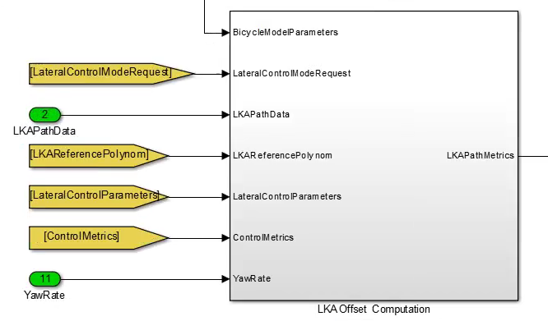

LKA的路径距离主要是车身到轨迹的距离，采用贝塞尔计算公式可以求解：

按照上述公式，提供LKA计算的初始速度和位置、24个点的加速度计值，即可计算出轨迹点的位置偏差。

#### 4.2.3 TJA Offset Computation

Path: LatCtrl – Compute Control Metrics – TJA Offset Computation

The TJA Offset Computation-block computes the local offset Δy, thelookahead offset yL2, the local heading LocalHeading, the effective lookahead time Teff and the effective lookahead distance Leff.All of these metrics are stored in a vector signal named TJAPathMetrics.

|  |  |  |  |  |
| --- | --- | --- | --- | --- |
| Input | Signal | Dim. | Data type | Description |
| TJAPathData |  |  |  | Vecor signal containing three elements[SplineX,SplineY,ValidSamples] |
| LateralControlParameters |  |  |  | Control parameters |
| ControlMetrics |  |  |  |  |
| BicycleModelParameters |  |  |  | BicycleModel parameters |

|  |  |  |  |  |
| --- | --- | --- | --- | --- |
| Output | Signal | Dim. | Data type | Description |
| TJAPathMetrics |  | 6 | single | Vector signal has six fields[Δy,yL2,LocalHeading,Teff,Leff,ValidRange] |

TJA的路径距离主要是车身到轨迹的距离，计算方法主要采取Cubic曲线拟合的方法进行计算。

首先计算每两个点之前的斜率k值

进而计算出每段之间的系数a和b

根据比例关系：

即可得到点到线的距离为：

#### 4.2.4 Slip Compensation

Path: LatCtrl – Compute Control Metrics – Slip Compensation

The lookahead offset yL2 may be compensated for slip as previously described in following, the metric LocalHeading may also be compensated for slip.

#### 4.2.5 Create Control Metrics

Path: LatCtrl – Compute Control Metrics – Create Control Metrics

The Create Control Metrics-block stores metrics in a vector signal that is used in the Path Controller-block and the Limit and Format Output-block

|  |  |  |  |  |
| --- | --- | --- | --- | --- |
| Input | Signal | Dim. | Data type | Description |
| LateralControlModeRequest |  |  | single | LateralControlMode from LKA Controller |
| PathMetrics |  |  | bus | Path parameters |
| LateralControlParameters |  |  | bus | Control parameters |
| VehicleSpeed |  |  | single | Vehicle velocity |
| LatCtrlTestBus |  |  | bus | Test LatCtrl parameters |
| DILFactor |  |  | single | Driver in loop parameter |
| TorqueLimitActivation |  |  | bool | PSCM torque limit activation parameter |
| PinionAngle |  |  | single | Vehicle SteerAngle |
| VLatError |  |  | single | No used |



Control Gain Table

控制系统在除了系统在增益表设计初始值以外，系统还设计了一个自适应调参算法，主要的算法步骤如下：

1、将PinionAngle通过高通滤波器，取1s中的均方差值，通过查表映射乘方向盘的活跃度，与设定的目标活跃度相减，设定为一个动态变量eActivity

2、根据驾驶员是否介入、位置Δy的大小和动态变量eActivity，计算出动态参数的变化率

3、计算动态参数，采用一阶积分，得到动态参数值

4、将系数与设定的Koffset、Kp、Ki、Kd系数相乘、得到最后用于控制的参数列表

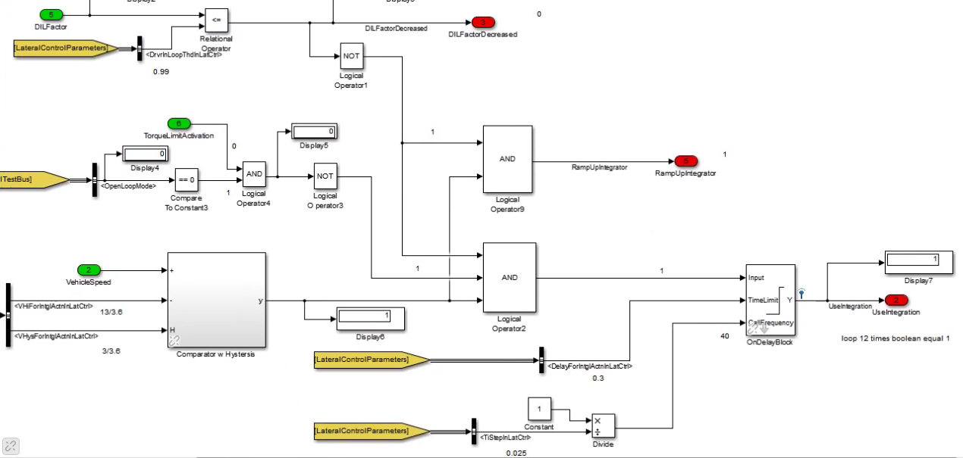

控制积分项是否使用的条件设定：必须在速度大于13km/m，驾驶员没有介入的情况系，才可以使用积分项

### 4.3 Path Controller

Path: LatCtrl – Path Controller – LocalOffsetandVlatControllers

The Curvature Desired Derivation-block implements the lookahead offset control loop and the local offset control loop.

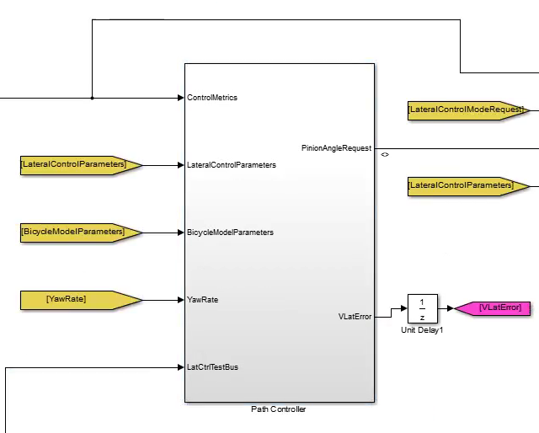

#### 4.3.1 LocalOffset and VLat Controllers

Path: LatCtrl – Path Controller –LocalOffset and VLat Controllers

The block can calucate the desire yawrate for the control system.

##### 4.3.1.1 LocalOffsetController

Path: LatCtrl – Path Controller –LocalOffsetandVlatControllers

–LocalOffsetController

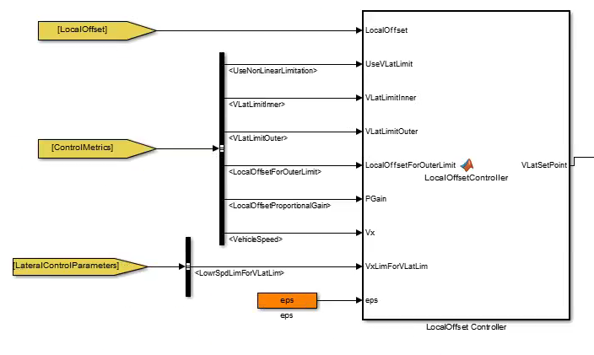

The LocalOffset Controller-block is used to Amplify the lateral local offset and requires a lateral vehicle speed. Output is limited to a tunable lateral vehicle speed



Vset=Koffset*Δy，带入上述的约束条件，使位置环控制的速度在约束条件内

##### 4.3.1.2 VlatController

Path: LatCtrl – Path Controller –LocalOffsetandVlatControllers

–VlatController

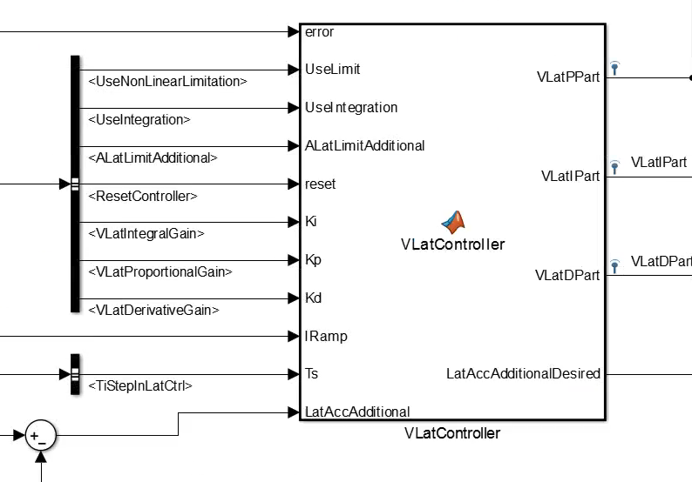

The VLatController-block is used to calculate for vehicle lateral speed(locally and relative path)

 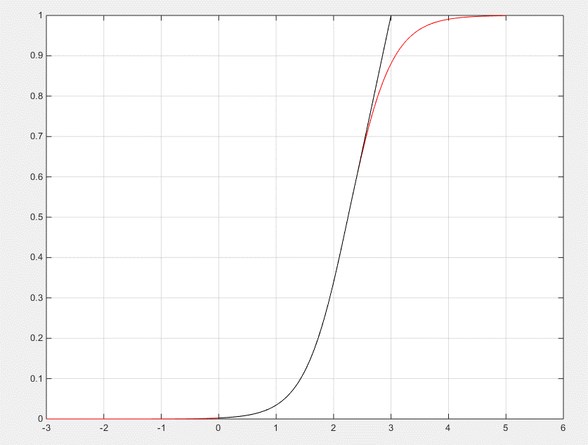

系统设计了一个ramp over的控制策略，对PID的积分项进行了动态的比例系数控制，在LKA控制3s内，积分项不是按照比例系数进行计算，PID的控制步骤如下：

1、左图为PID控制中积分项的比例系数控制策略

2、右图黑线是时间映射成比例系数的图形

3、控制算法

##### 4.3.1.3 CalcRampOver

Path: LatCtrl – Path Controller –LocalOffsetandVlatControllers

–CalcRampOver

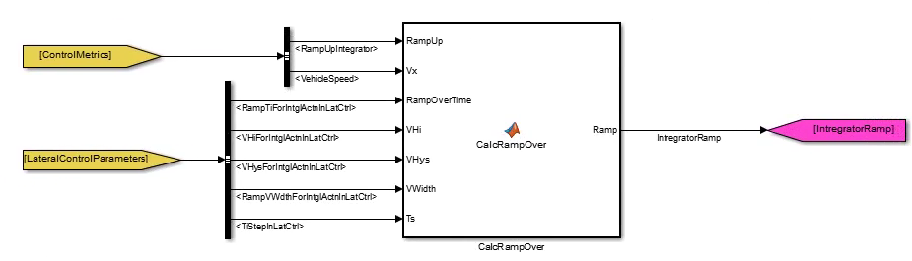

The RampOver-block is used to calculate the value of the parameter LocalOffsetRamp which is used to smoothly ramp in or ramp out the local offset integrator.

### 4.4 Limit and Format Output

Path: LatCtrl – Limit and Format Output

In the Limit and Format Output-block the requested pinion angle on the steering-wheel ,is bounded to . The derivation of is performed in a subsystem named Determine PinionAngle Limitation.

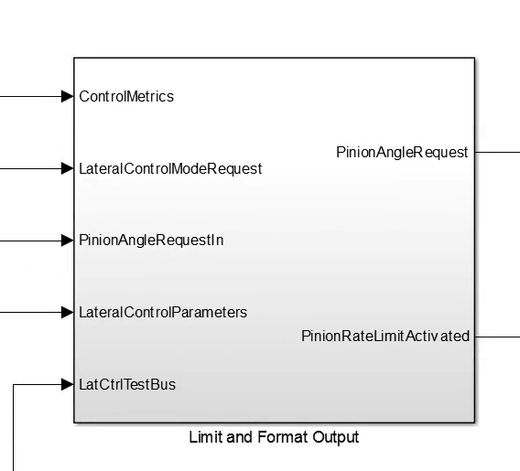

#### 4.4.1 Determine PinionAngle Limitation

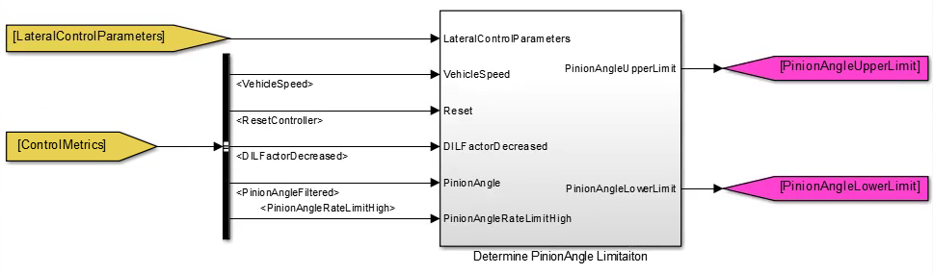

Determine Pinion Angle Limitation-block Calculate the upper and lower thresholds for the PinionAngle

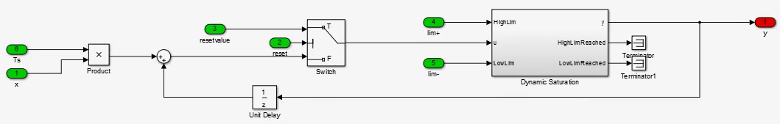

系统设定了标定量的值，在单位时间内，可以看到约束值为

计算得到角度的上下限值为

#### 4.4.2 Dynamic Saturation

Through Dynamic Saturation,system compute the pinion rate limit activated.